Assert:

Assert is used as condition if true then it will move forward otherwise it will give assertion error

We will use assert to check error in dataset like weather primary key is not repeated weather

Weather date is in correct format

1. Create source add source

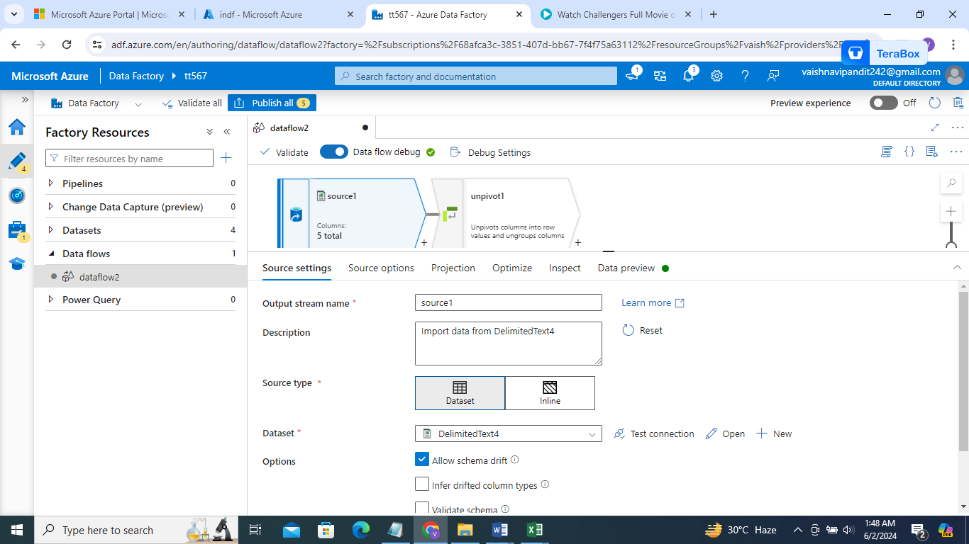

1. Now click on + and select assert

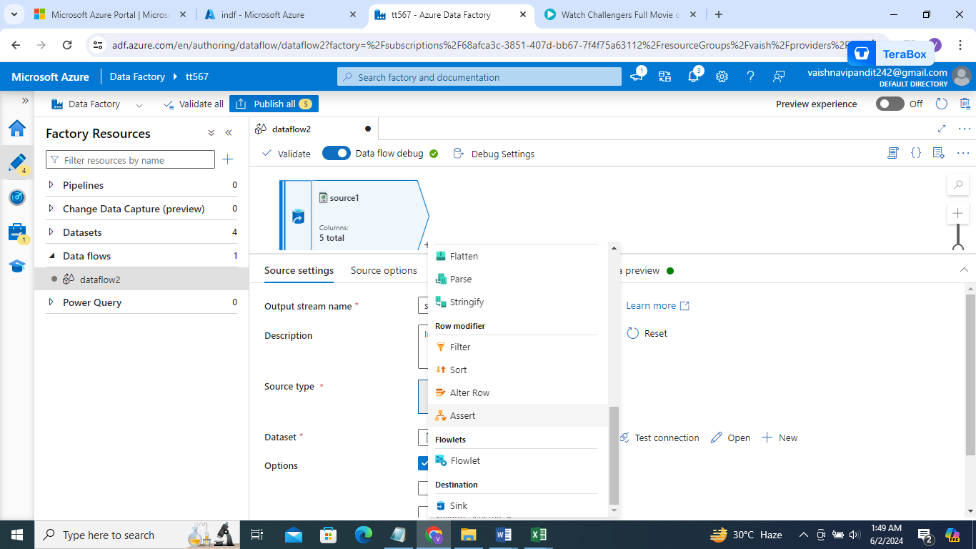

1. Click on assert

In assert 1

Select asser type expect true

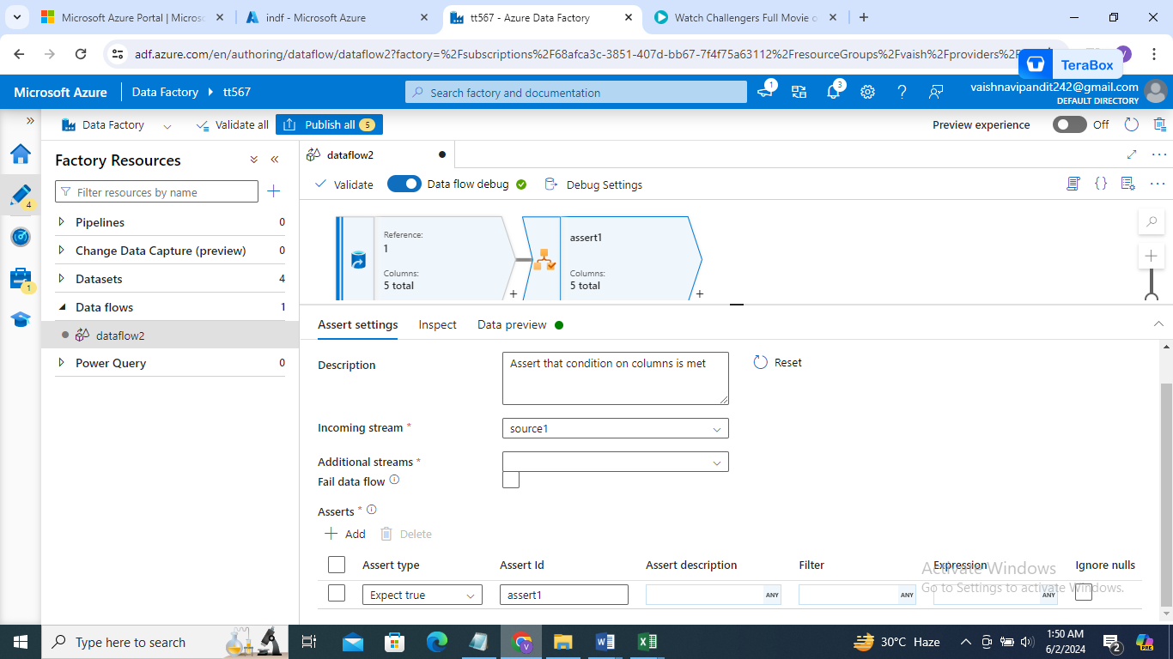

1. Add expression

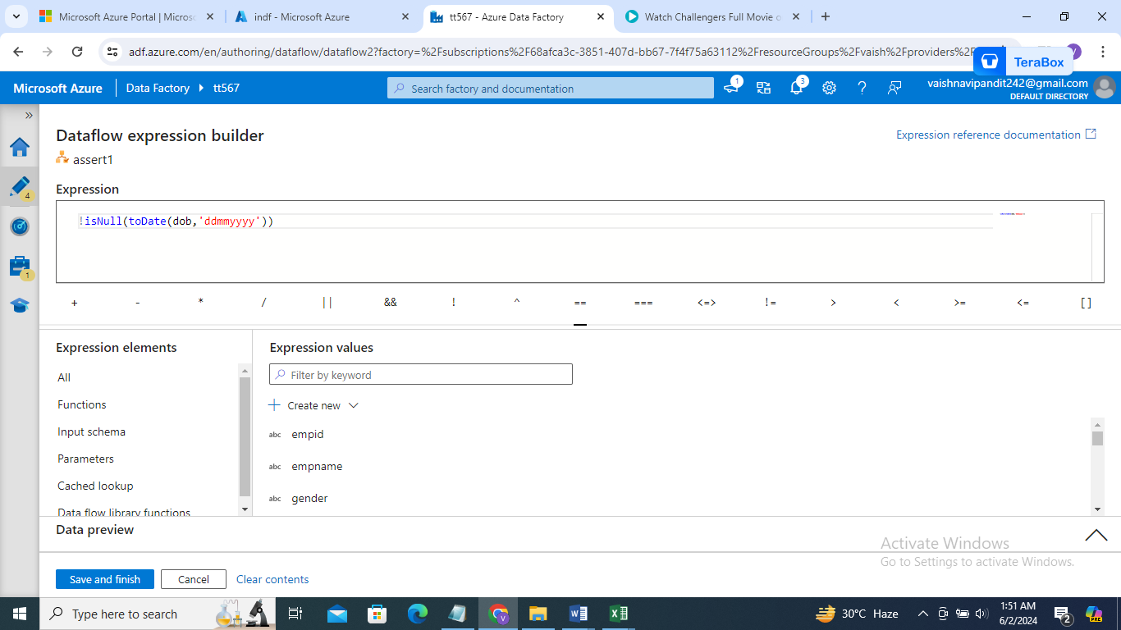

1. Create one more assert

Assert type expect unique

Expression=empid

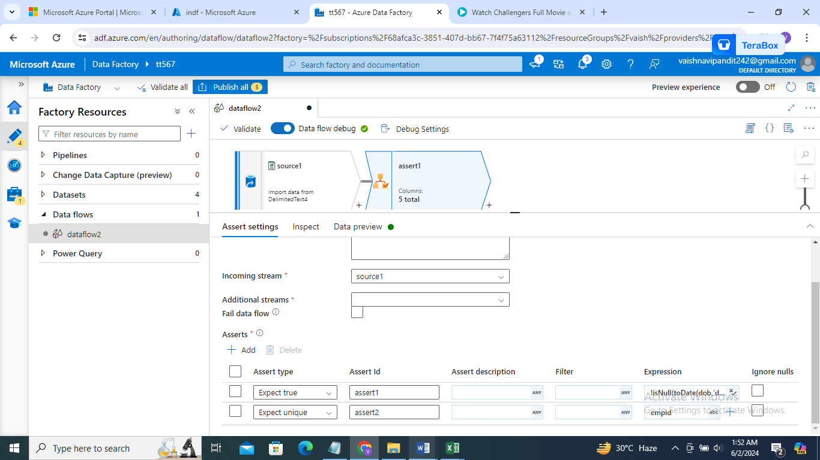

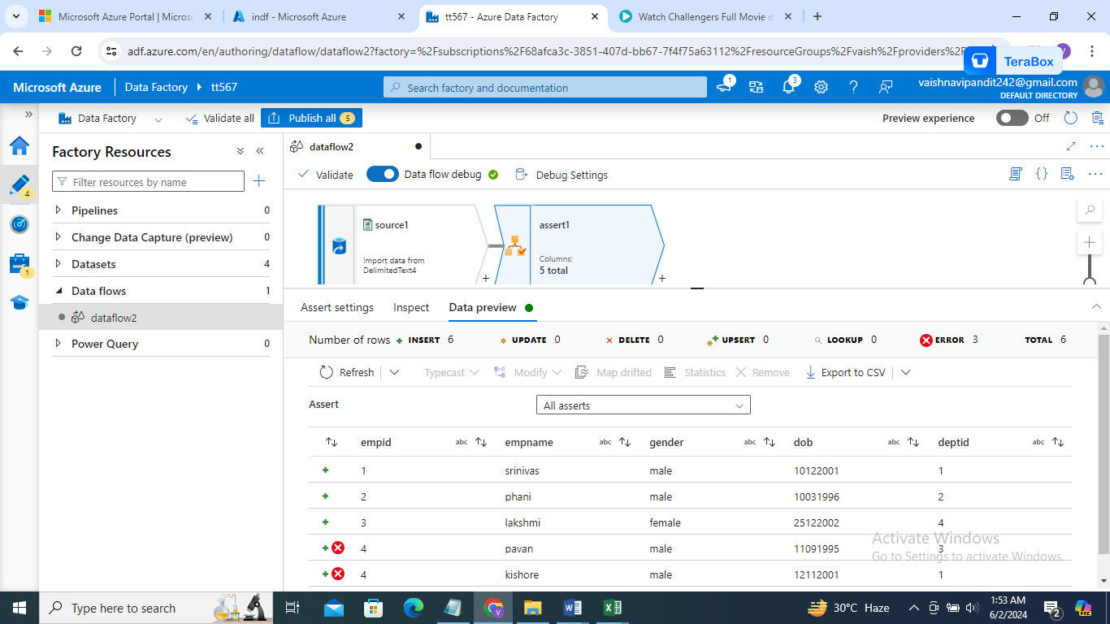

1. Now created derived column and add column name=iserror

Expression=iserror()

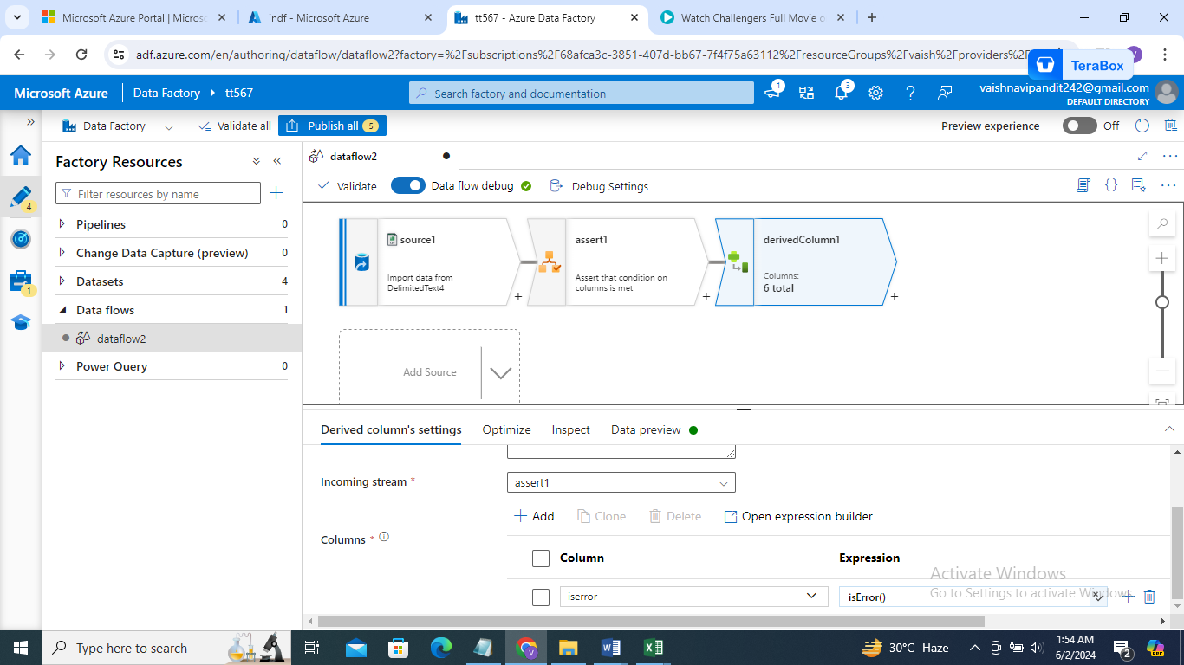

1. Now create filter activity so that only records without error will be sent to sink

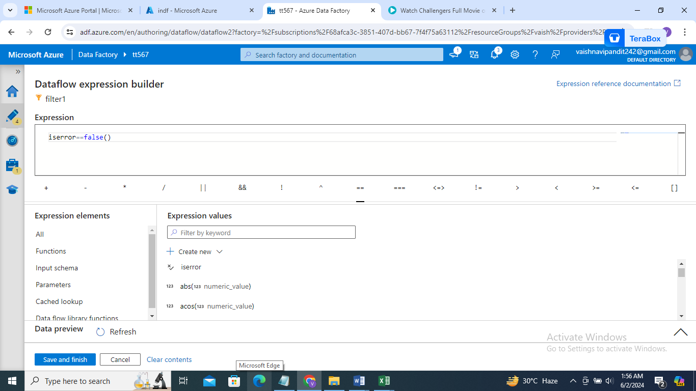

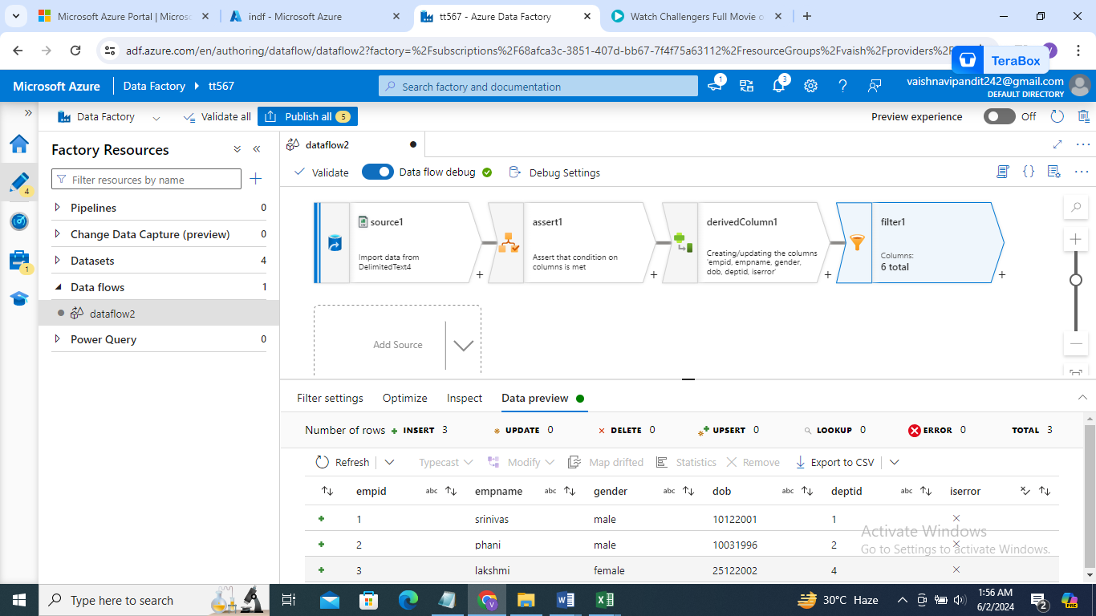

1. Now what if we have one more source and we wanr combine those on similar data only
2. Create source 2

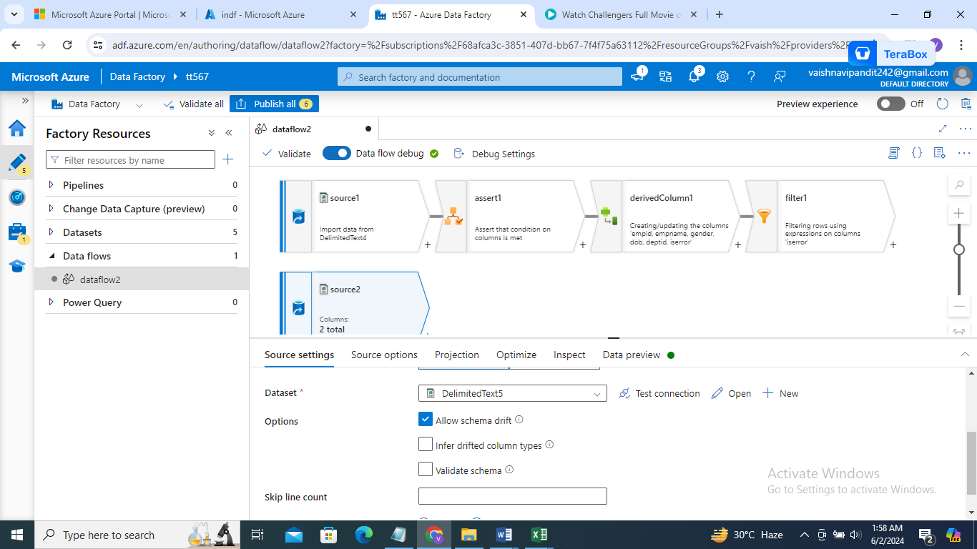

1. Go to assert

->additional incoming stream ->select source 2

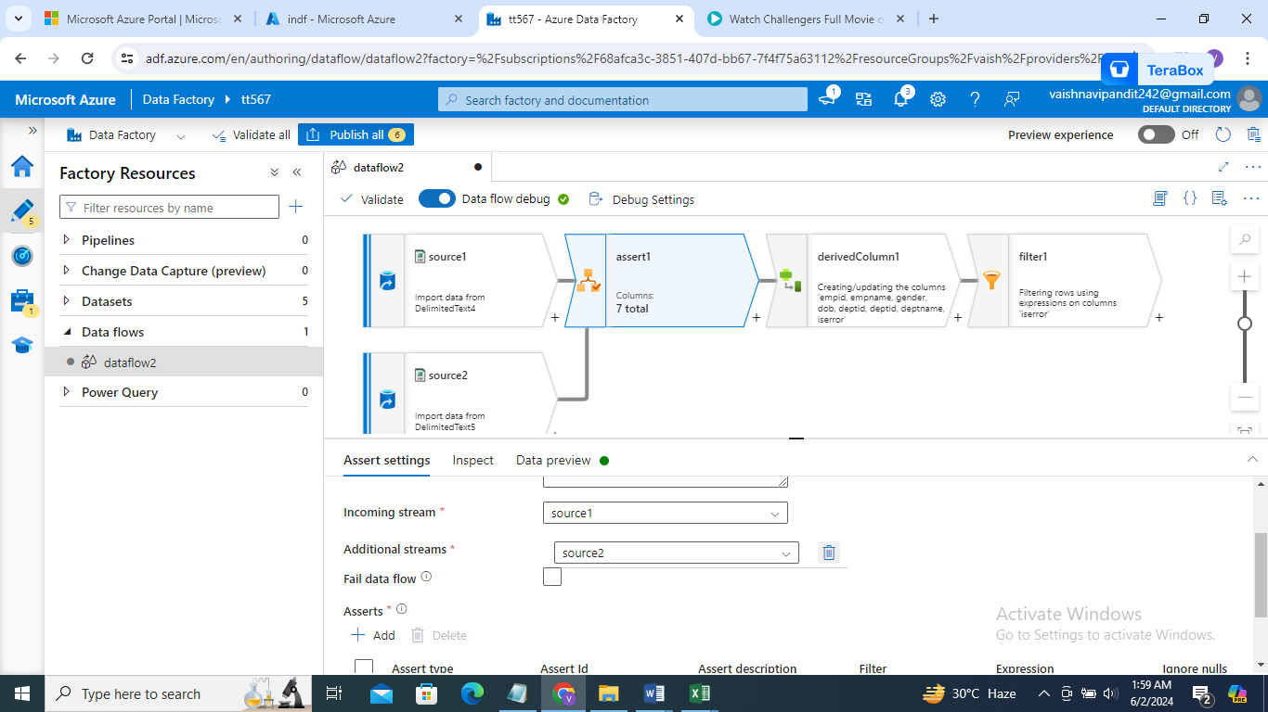

1. Add one more assert for exists

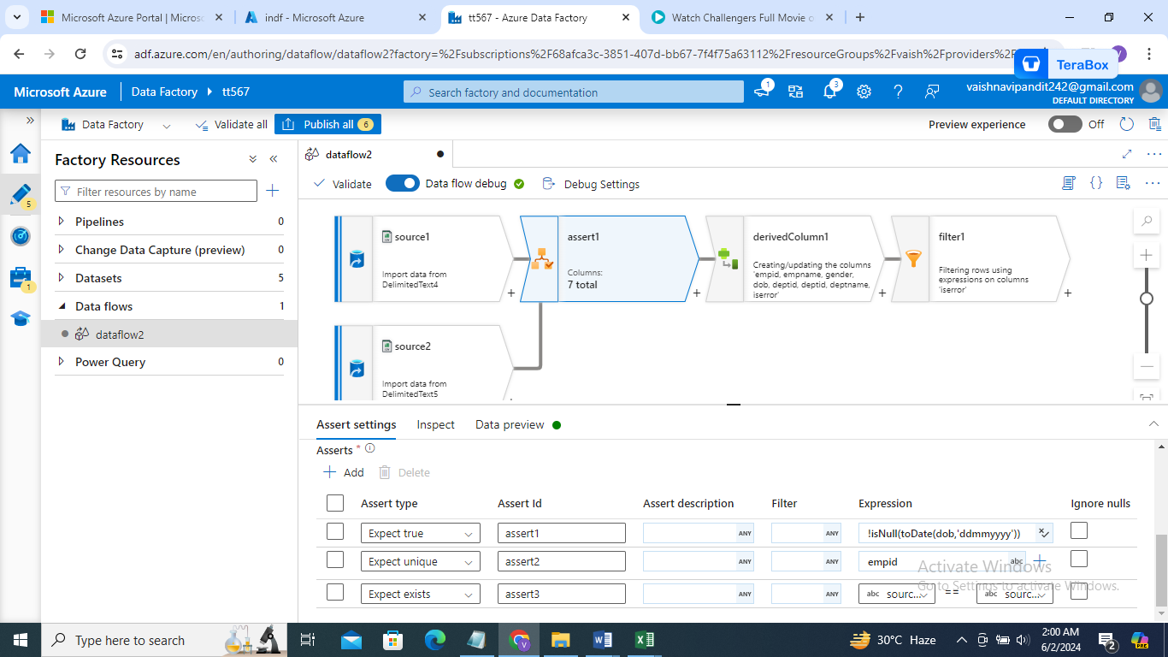

1. See preview

